LAWOCON LIMITED

Company Profile

***LAWOCON LIMITED***

***Genius delivery in good time***

***HISTORY AND PHILOSOPHY***

***LAWOCON LIMITED*** *is a building and civil engineering company, incorporated in the year 2011. Prior to its incorporation, the company had existed with its principal staff who had worked for and in partnership with public and private sectors, covering state government and international firms and meeting the needs of our clients whose focus is quality construction delivered on time and within budget.*

***LAWOCON LIMITED*** *takes on the role of main contractor for small and medium size projects and also offers project management services directly to clients and contractors. We also proffer design and build solutions and specialized construction, in areas pertaining to water retaining reinforced concrete structures.*

*Our primary objective is to guarantee the satisfaction of our clients in all ramifications, during and after project execution. Our emphasis on clear communication and follow through procedures ensures that the client’s objectives are of utmost priority from planning to execution stages.*

*Our project management and execution philosophy is:*

* *Create detail schedule and resource plan to meet clients project objective*
* *Communicate clearly with all project stakeholders*
* *Track project progress and fine-tune variations and deviations*
* *Supervise closely to ensure optimum quality control*
* *Complete and commission the project in record time*

*Quality assurance is placed on all project activities, particularly professional expertise, which is fundamental to long – term project quality. We give top priority to human reliability, because the quality of services provided by our firm is closely related to, and determined by human performance.*

***MISSION STATEMENT***

*We at LAWOCON LIMITED are dedicated to providing high quality building and civil engineering construction capable of meeting international standards within our clients budget.*

***OUR TEAM***

*Our team comprises of seasoned architects, engineers, quantity surveyors and builders who have garnered experience over the years from various projects. We also have a robust administrative team which oversees the smooth running of our organization*

***PROJECT MANAGEMENT AND TECHNICAL TEAM***

*Engr. Lawani Omoghagbon - General Manager*

*Engr. Dage Johnson (MNSE/COREN) - Project Manager*

*Arc Nelson Beniowu Architect*

*Arc Daniel Awano Architect*

*Engr. Femi Ayinla (MNSE/COREN) Structural design lead*

*Engr. Olugbenga Oyinlade (MNSE/COREN) Services Engineer*

*Mr Emmanuel Oigboke Quantity Surveyor*

*Mrs Evans Onyebuike Quantity Surveyor*

*Field Workers Both Permanent and Casual*

***ADMINISTRATIVE STAFF***

*Miss Onyinyechi Adah – (HND) Admin. Secretary /Human Resource Manager*

*Barr. Onaivi Otokunrin Legal Adviser*

*Alilu Usman - (Bsc.) Accountant*

*Chinelo Anozie Receptionist*

*Auxillary Staff Drivers and Office Assitants*

***EQUIPMENT ROLL***

|  |  |  |
| --- | --- | --- |
| **S/NO** | **DESCRIPTION** | **NO** |
| **1** | **10 TYRE TIPPING TRUCK** | **2** |
| **2** | **6 TYRE TIPPING TRUCK** | **2** |
| **3** | **CRANE LORRY** | **1** |
| **4** | **CONCRETE MIXERS** | **4** |
| **5** | **WATER TANKER** | **1** |
| **6** | **10 KVA GENERATING SET** | **2** |
| **7** | **4.2 TONS PICK UP TRUCK** | **1** |
| **8** | **TOWER LIGHTS** | **5** |
| **9** | **5HP WATER PUMPS** | **3** |
| **10** | **ROLLER COMPACTING MACHINE** | **1** |

***PROJECT REFERENCES***

|  |  |  |
| --- | --- | --- |
| **YEAR** | **PROJECT DESCRIPTION** | **OWNER/MAIN CONTRACTOR** |
| **Feb 2015** | Main contractor for laying of underground storm water pipes and construction of associated manholes and culverts for Heritage estate, Kukwaba district Abuja | King Snazzy Global Nig LTD |
| **Aug 2014** | Main contractor for construction of 6 bedroom duplex in Festrut Estate, Katampe Hills by Aso Radio, Abuja | Engr. Don Ojemaye |
| **July 2014** | Main contractor for Remodellling and renovation of 6 bedroom bungalow and Boys Quarters ,Obollo, Isiala Mbano LGA, Imo State | Mr Basil Nwunze |
| **April 2014** | Main Contractor for renovation of 4 nos of Terrace Duplexes in Kabusa Garden estate, Abuja | SFS NIG. LTD |
| **Feb 2014** | Main contractor for remodeling and renovation of 9 bedroom duplex and associated interlocking pavement and external works  Construction of multipurpose storey building, housing guest house, chapel and two units of 2 bedroom flats.  Construction of a 5 bedroom bungalow | Sir Sonny Elebo |
| **Oct 2013** | Project management for construction of a block of 4 nos of 3 bedroom flats to serve as Vicarage for St Andrews Anglican Church Kubwa, Abuja. | Kubwa Archdeaconary, Anglican Communion |
| **April 2013** | Project management for construction of 6km “ Ofagbe-Egwi-Ibuku” road ,Isoko north LGA, Delta State | Best Amadi LTD |
| **Dec 2012** | Project management for construction of Guaranty Trust Bank E-Branch, Eagle square. Abuja | KIT-TIN LTD |
| **Sep 2012** | Main contractor for completion of 3 bedroom bungalow from roofing carcass stage, Sunshine estate, Gwarinpa . Abuja | ZAKAHALA NIG LTD |
| **Sep 2011** | Project management for construction of Guaranty Trust Bank, Yola Town, Adamawa State | KIT-TIN LTD |
| **Mar 2011** | Construction of 2 nos of 4 bedroom duplexes and 3 nos of 4 bedroom bungalows in Pengassan Housing Estate phase 3, lokogoma district, Abuja. | BROOKMOORE LTD |

***VISUAL TOUR***

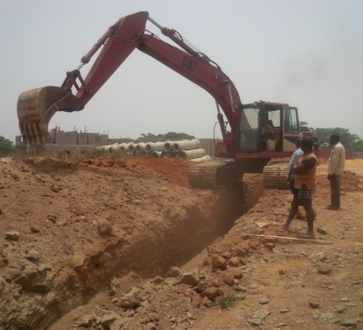 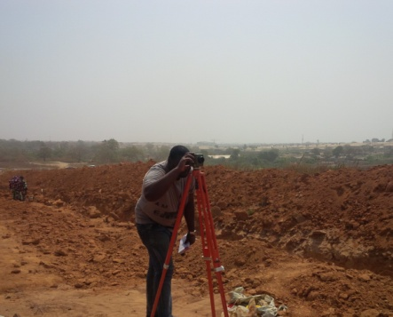 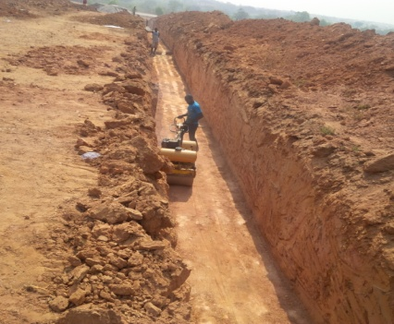

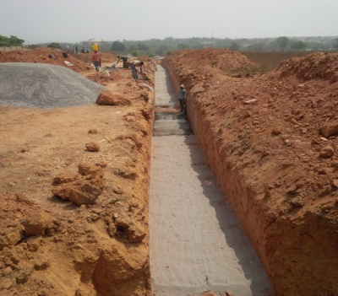 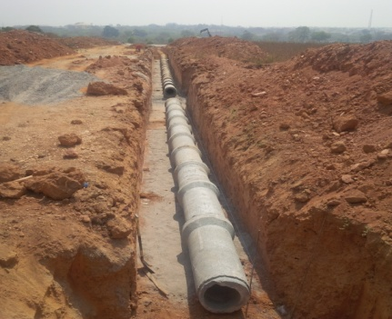 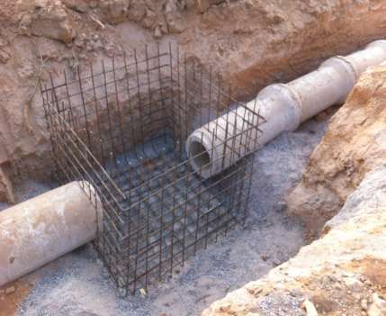 l

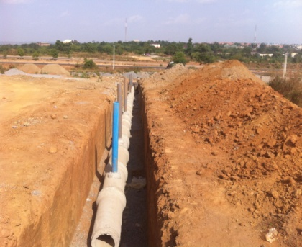 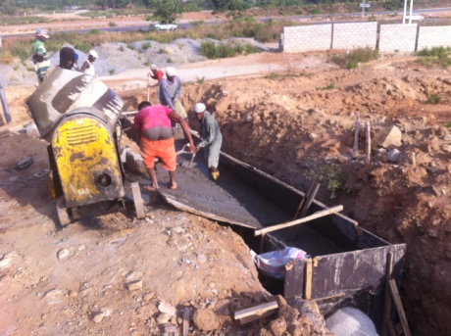 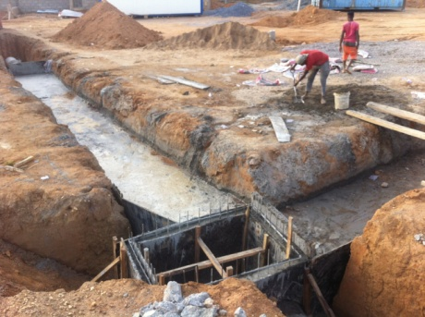

***UNDERGROUND STORMWATER DRAINAGE WORKS***

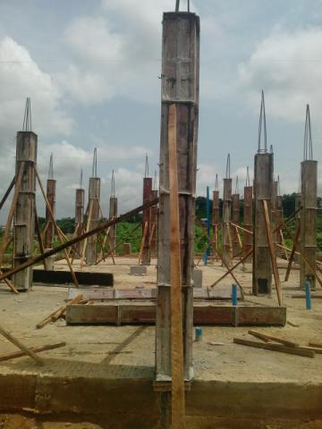 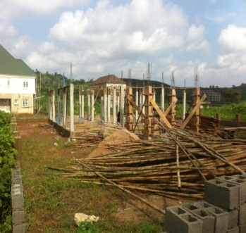 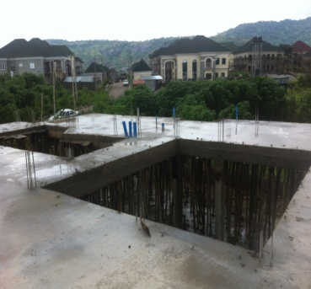 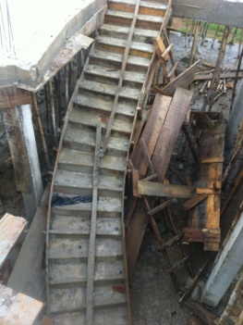

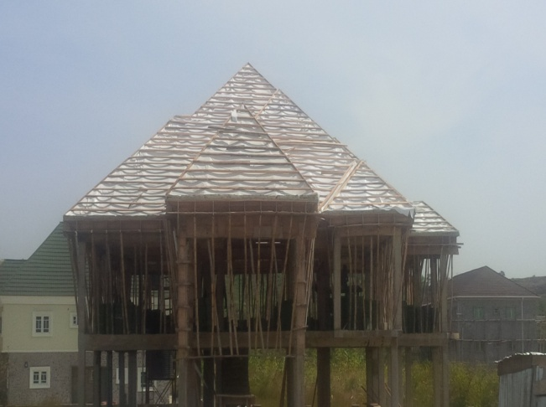 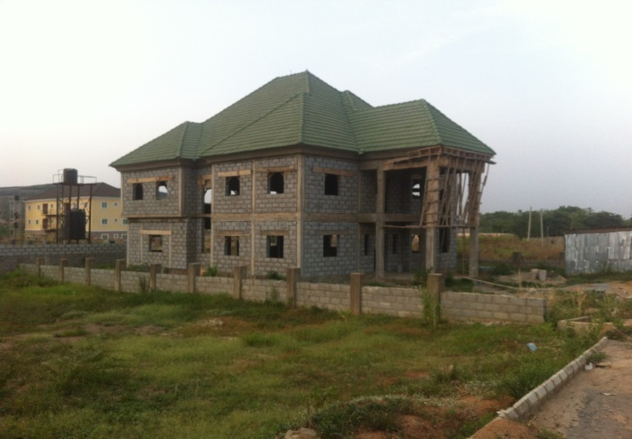

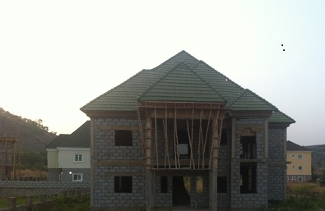

***SIX BEDROOM DUPLEX DEVELOPMENT IN FESTRUT ESTATE ABUJA***

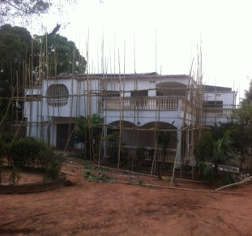 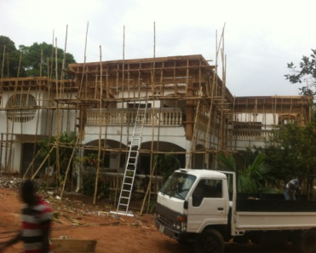 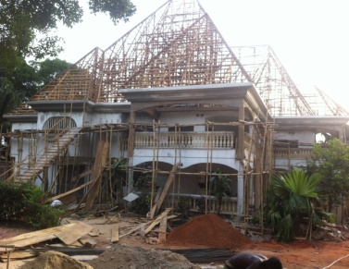 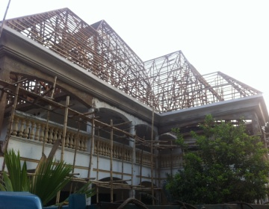

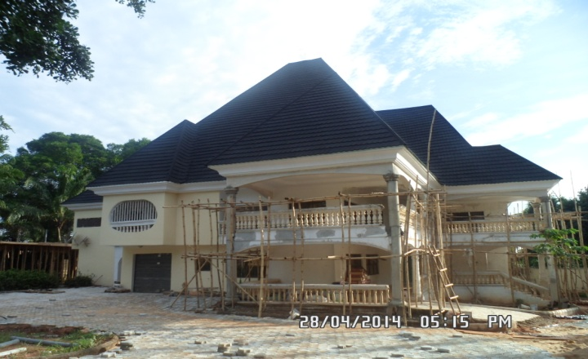 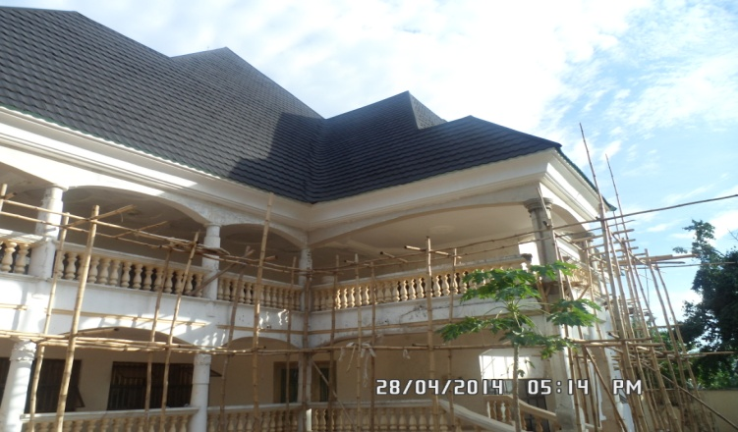

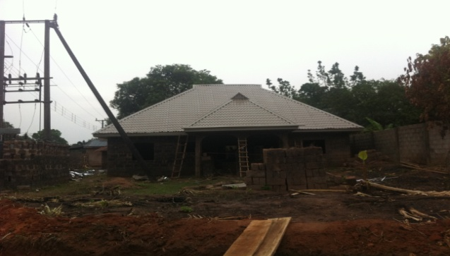 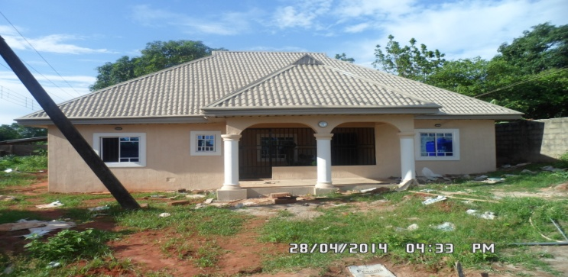

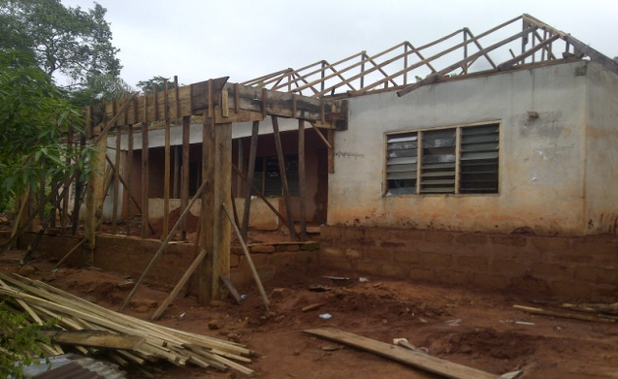 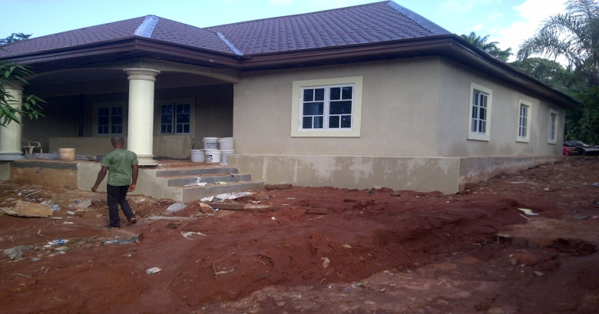

***RENOVATION AND REMODELLING JOBS***

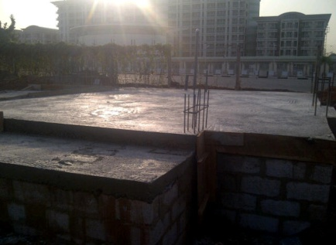 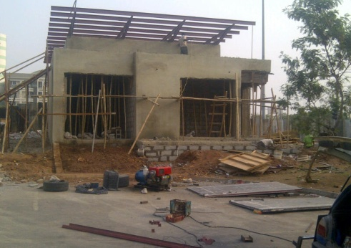 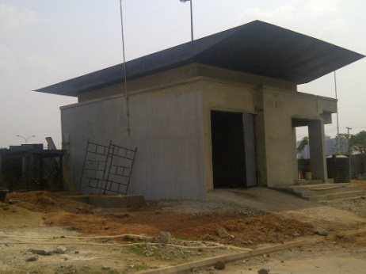

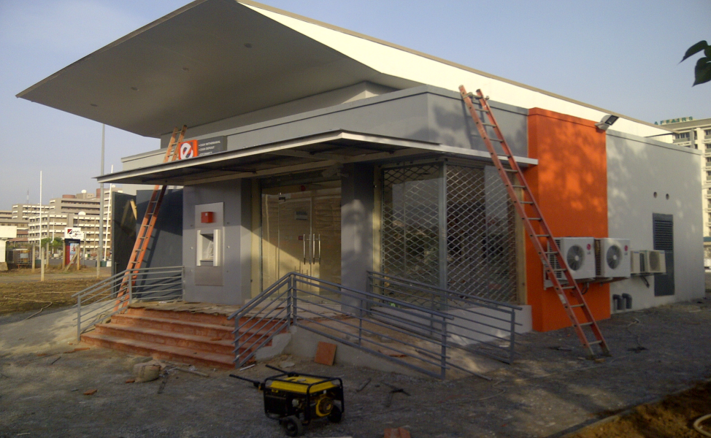

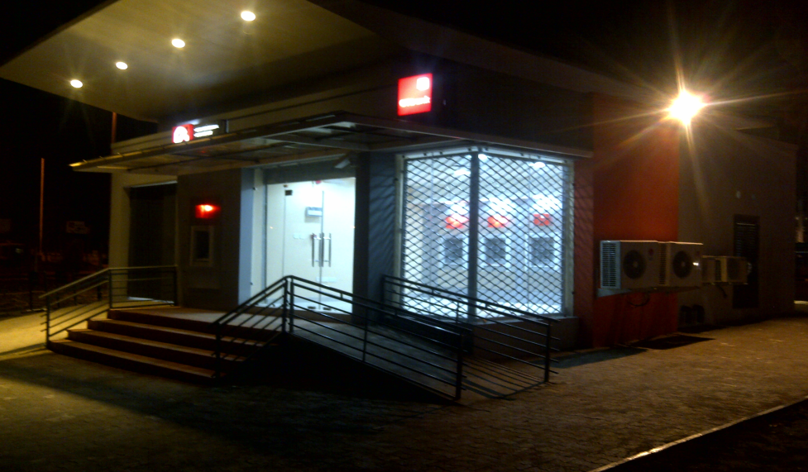

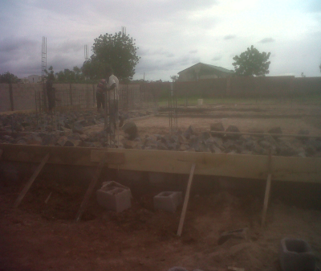 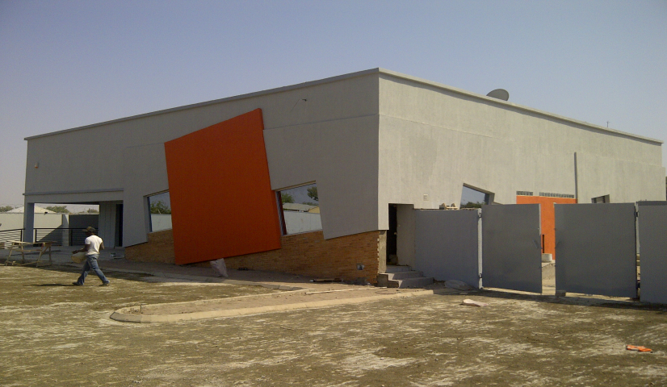

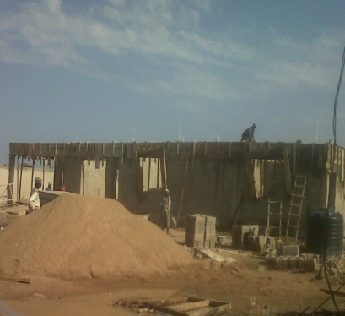 ***PROJECT MANAGEMENT FOR G.T BANK YOLA TOWN AND EAGLE SQUARE***

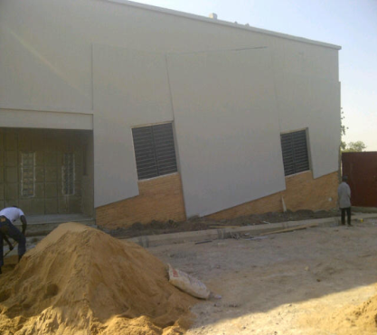 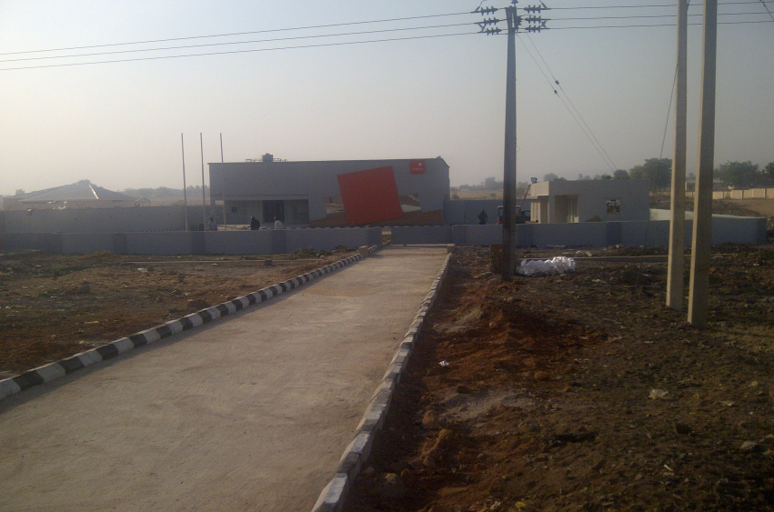

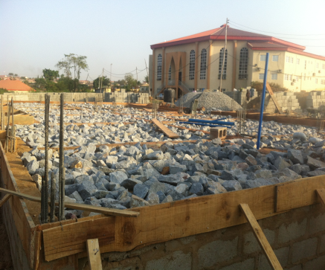 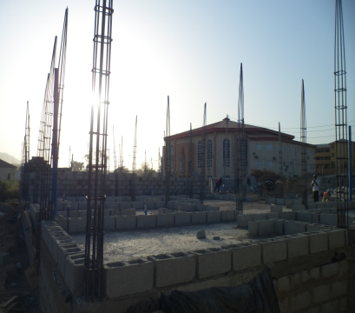 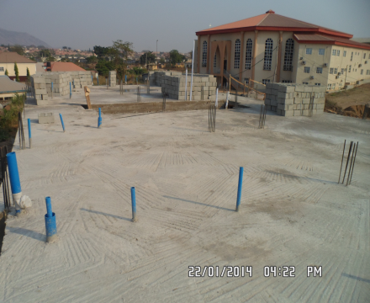

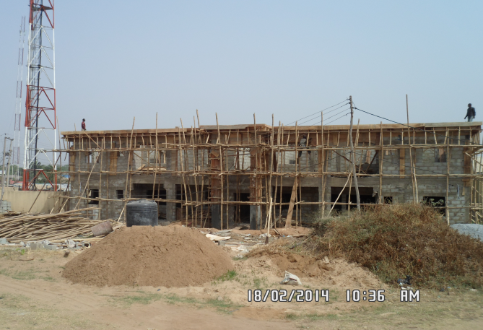 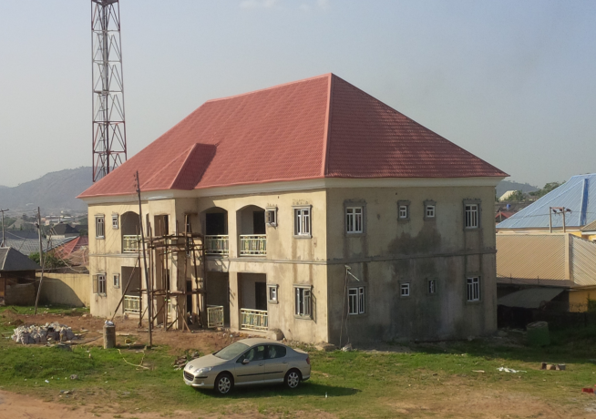

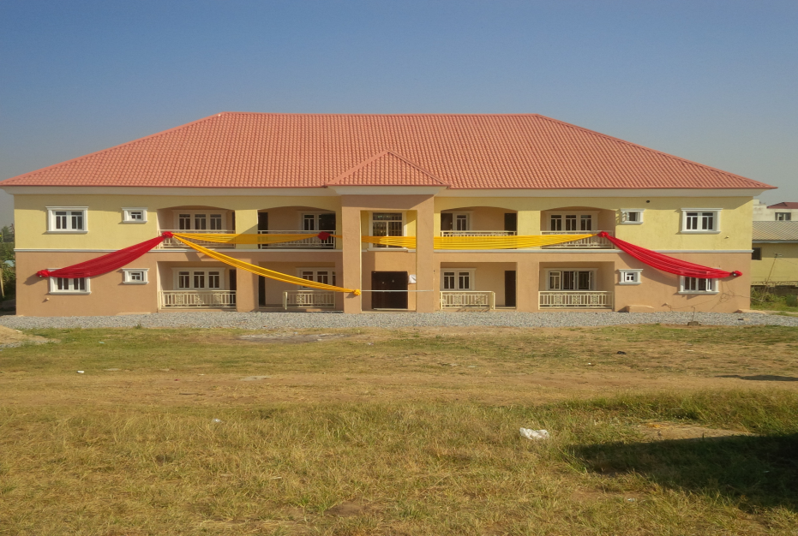 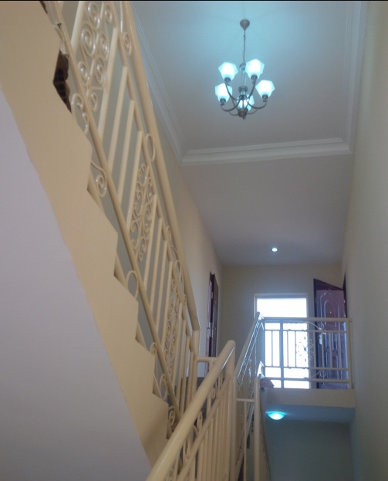

***VICARAGE FOR ST ANDREW’S ANGLICAN CHURCH***

***SPECIALIZED SWIMMING POOL CONSTRUCTION***

*At LAWOCON LTD we take a different approach to swimming pool construction, by casting both the walls and base of the pool together. This method has proven to be the best measure to prevent joints between the wall and base, and hence eliminate incidence of leakages and seepage from those joints. Leakages from the joints occur even with the use of waterguard in conventional construction.*

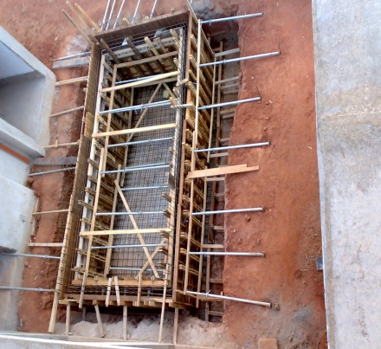 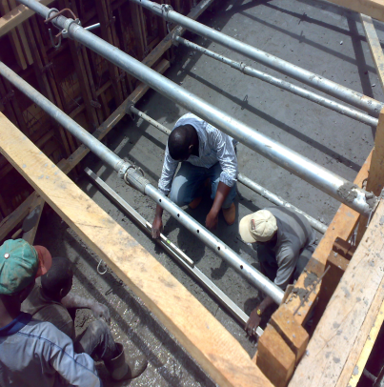 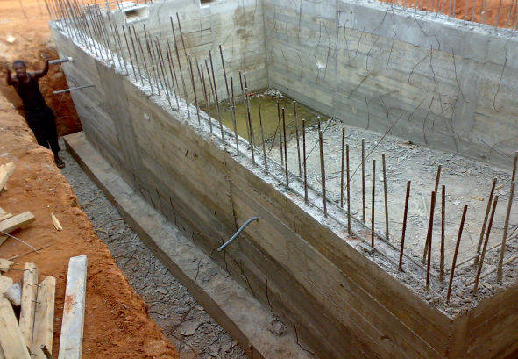

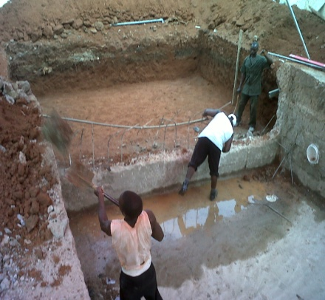 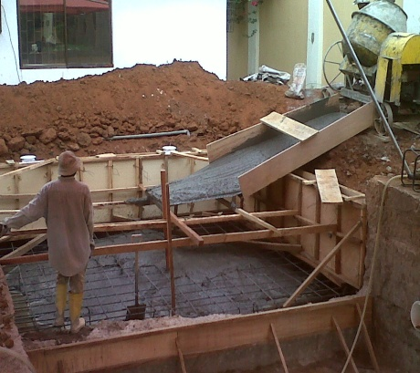 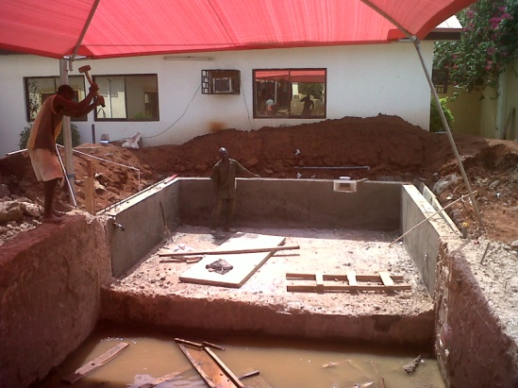

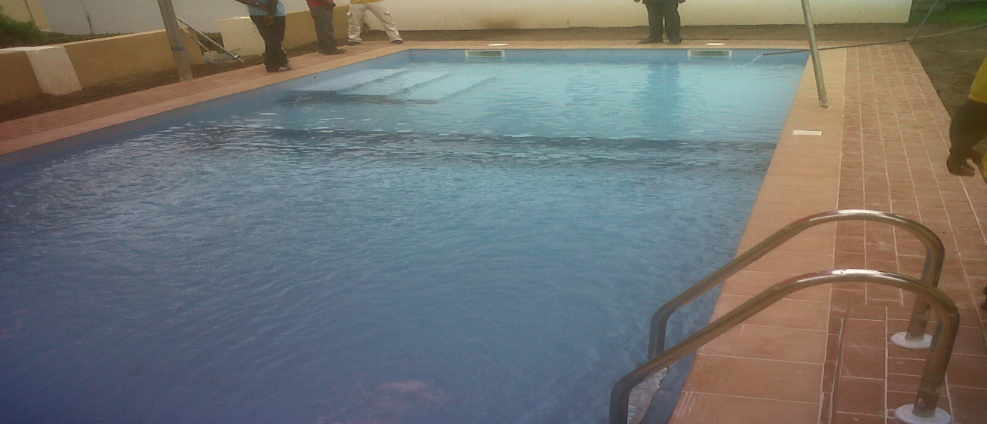

**Contact Details**  
Tel: +234 803 412 2200  
Tel: +234 805 669 1962

Tel: +234 706 225 7846

Email: [Lawoconprojects@gmail.com](mailto:Lawoconprojects@gmail.com)

**Our Location**  
2nd Floor WAEC Building,

10 Zambezi Crescent,

Maitama. Abuja